NAME
SUBJECT | TECHNICAL DRAWING 1 & 2 | CLASS | SS 1 | DURATION | 2 HOURS

INSTRUCTIONS: This booklet consists of two papers. Answer paper 1 in your objective Test answer sheet and paper 2 in your drawing sheet.
PAPER 1
OBJECTIVES (40 MARKS)

- Which of the following figures does not have edundant dimensioning?
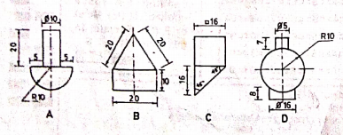

- In a regular decagon, the interior angle is ___________
- 144⁰
- 135⁰
- 108⁰
- 120⁰
- In representative fraction, the ratio of the numerator to denominator is _________
- shows the ratio of the drawn size to the natural size
- shows the ratio of natural size to the drawn size
- represents the number of times the actual size is drawn
- denotes the actual size of the drawn object
- How many faces has a tetrahedron?
- Four
- Five
- Six
- Seven
- A triangle whose side ratio is 4:7:4 is _____ triangle
- scalene
- isosceles
- equilaterals
- right angled
- The locus of a point on the circumference of a circle as the circle rolls without slipping along a straight line is
- trochoid
- epicycloid
- hypocycloid
- cycloid
The figure shows above is the construction of a parabola, use it to answer questions 7 and 8
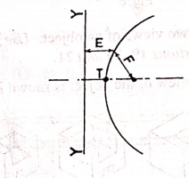
- The part labelled Y-Y is ___ _______
- a vertex
- an axis
- a directrix
- a focus
- If F is 20, E is ______
- 15
- 20
- 25
- 30
- The figure shows below is the elevation of a triangular pyramid cut by plane Y-Y. The developmentis shown in
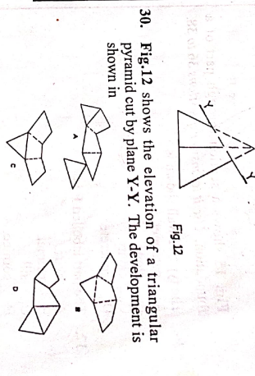
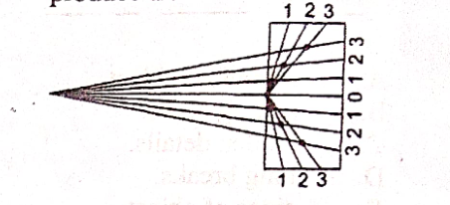
- If the points on the drawing below are joined and outlined, it will produced a/an

- hyperbola
- involute
- parabola
- hypocycloid
- Which of the following statement is correct about the drawing below?
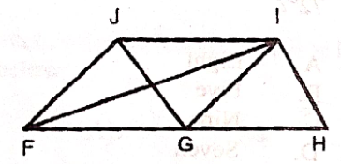
- FGIJ is aparallelogram
- FH and JI are equal
- FI and HI are parallel
- GHIJ is a square
- Which of the following method is used to develop a prism?
- Radial
- Parallel
- Triangulation
- Approximate
- Which of the following are true about □25 in the diagram below?
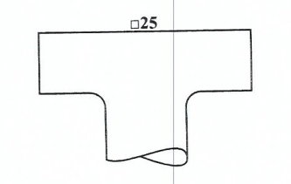
- It is an abbreviation for radius
- It indicates that the surface is square
- It avoids using a second dimension
- It indicates that the drawing is in first angle projection
- I and II
- I and III
- II and III
- II and IV
- Which 0f the following construction is illustrated below?
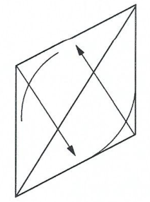
- Construction circles
- Construction of parabola
- Irregular curve
- Circle in isometric
- The unfolding of an object into a flat sheet called pattern is referred to as ___
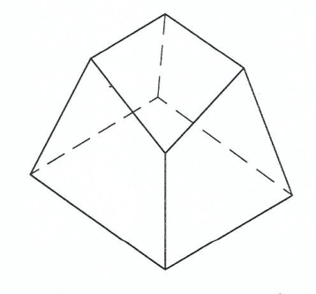
- bisecting
- loci
- developing
- machining
- The diagram below illustrate the proper method of
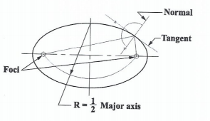
- constructing an ellipse with tammel method
- Construcing hyperbola as conic section
- Finding foci, the normal and the tangent of an ellipse
- Finding the foci, the normal and the tangent of a parabola
- Which of the diagram below best represents internal and external tangent to two circles?
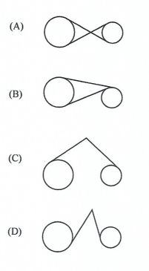
- If a car picks up a tack on circumference of one of its tyre, then the path traced by the tack as the car is driven is called
- a hyperbola
- a parabola
- a cycloid
- a involute
- The sketch below shows the development of
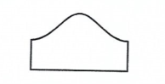
- truncated prism
- truncated cylinder
- truncated pyramid
- cylinder
- Which of the following development shows a cylinder which is cut obliquely at both ends?
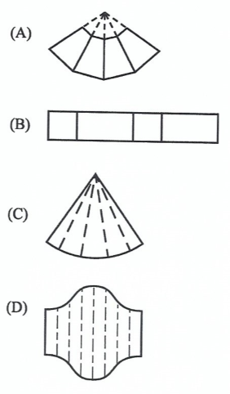
- Which of the following instruments is used when drawing an irregular curve on a surface development?
- Isometric template
- French curve
- Compass
- Bow pen
- The use of radial line method is s most suitable for the development of _____
- right cone
- cylindrical piep
- oblique pyramid
- cube
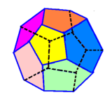
- The regular polyhedral shown below is _____

- icosahedron
- octahedron
- dodecahedron
- tetrahedron
- A development of an object is a drawing showing
- one view
- two views
- pictorial sketch
- the unfolding of the surface
- The figure below shows the construction of _____
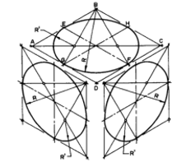
- ellipse
- isometric circle
- circle
- oblique circle
- Which of the following is a view of a square pyramid?
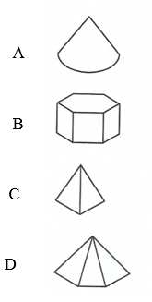
- A polyhedron with two end join by rectangular faces is called.
- prism
- regular
- pyramid
- revolution
- In the dimensioning , the line labelled K is referred to as _______ line
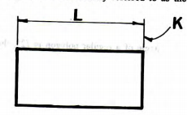
- Reference line
- datum
- directrix
- vertical
- A students falls and hits head hard against the edge of technical drawing table. He is most likely to suffer from a
- Concussion
- Laughing fit
- Heart attack
- Nervous breakdown
- Which of the number dimension below represents location dimensioning?
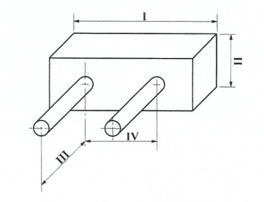
- I
- II
- III
- IV
- Which of the following is NOT a method of constructing ellipse?
- Rectangular
- Radial
- Trammel
- Approximately
- The figure below shows a right cone cut by plane XX parallel to side JK. What is the true shape of the cut surface?
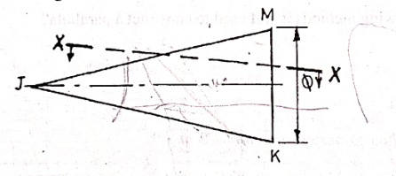
- Helix
- Parabola
- Hyperbola
- Ellipse
- A circle appears as _____in isometric projection.
- sphere
- circle
- ellipse
- torus
- Which of the construction below shows the unwinding of a string from a circle freely.
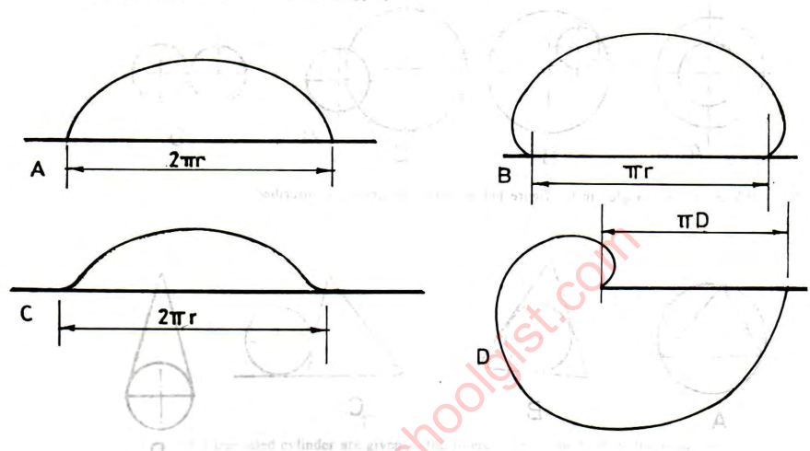
- Which of the following is NOT required to construct a parabola?
- Directrix
- Focus
- vertex
- minor axis
- Which of the following method is not used to construct hyperbola?
- Trammel method
- Rectangular method
- Circumscribing rectangle method
- Loci method
- Which of the following curves has eccentricity less than one?
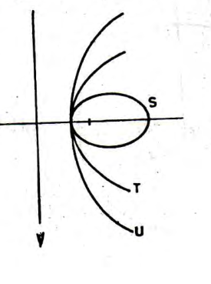
- S
- U
- T
- V
- The figure below is ______
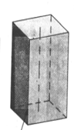
- Right prism
- Oblique prism
- Truncated prism
- Frustum of prism
- The solid figure shown below is ______
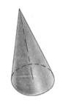
- right cone
- oblique cone
- truncated cone
- cycloid
- The indication of size, shape and other information on drawing is
- dimension
- written
- lettering
- alphanumeric

PAPER 2
GEOMETRY
(60 MARKS)
Answer three questions from this Part.
- (a) The sketch in Figure shows points M and N, 50 apart. Point P moves such that its distance from M and N is always in the ratio of 2:1.
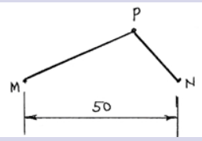
Plot the locus of point P for one revolution.
Technical Drawing 2, May/June 2023,Q.3a (10 marks)
b. The major and minor axes of an ellipse are 110 mm and 80 mm respectively. Construct
(a) the ellipse using focal points method;
(b) a tangent and a normal to the ellipse at a point P above the major axis and 30 mm from the right end of the major axis. WASSC 2008, Q.2 (10 marks)

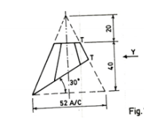
(a) . The figure above Shows a truncated hexagonal pyramid. Draw full size and first angle orthographic projection the:
i. The given view (5 marks)
ii. end elevation in direction of arrow Y. (5 marks)
iii. plan (3 marks)
iii. The surface development with T-T as the seam. (7 marks)
Technical drawing 2, WASSCE (PC2nd) 2020, Q. 2

- The figure below shows the front elevation and incomplete plan of a truncated square pyramid
(a) copy the given views (7 marks)
(b) complete plan (7 marks)
(c) construct the surface development (without base) using P-P as the seam (10 marks)

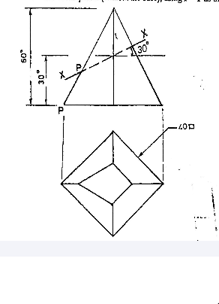

Technical drawing 2, May/june 2011. Q. 3
- (a) Construct an involute to circle R20, starting from the lowest point of the circle and in a clockwise direction. (12 marks)
(b) Draw a tangent to the involute at a point P, which is located on the involute 70 to the roght of the vertical centre line. WASSCE (SC) 2021, Q.3 (8 marks)

